MACH4METAL

metalworking machinery
Transito 21
6909 DA BABBERICH Netherlands
Tel. +31 (0)316-247123
Fax: +31 (0)316-247956
info@mach4metal.com
www.mach4metal.com

Bank No : 66.52.13.883
IBAN : NL33 INGB 0665 2138 83
BIC : INGBNL2A

WELE AA 1680 / TOYODA FV 1680

- Make : WELE - Taiwan
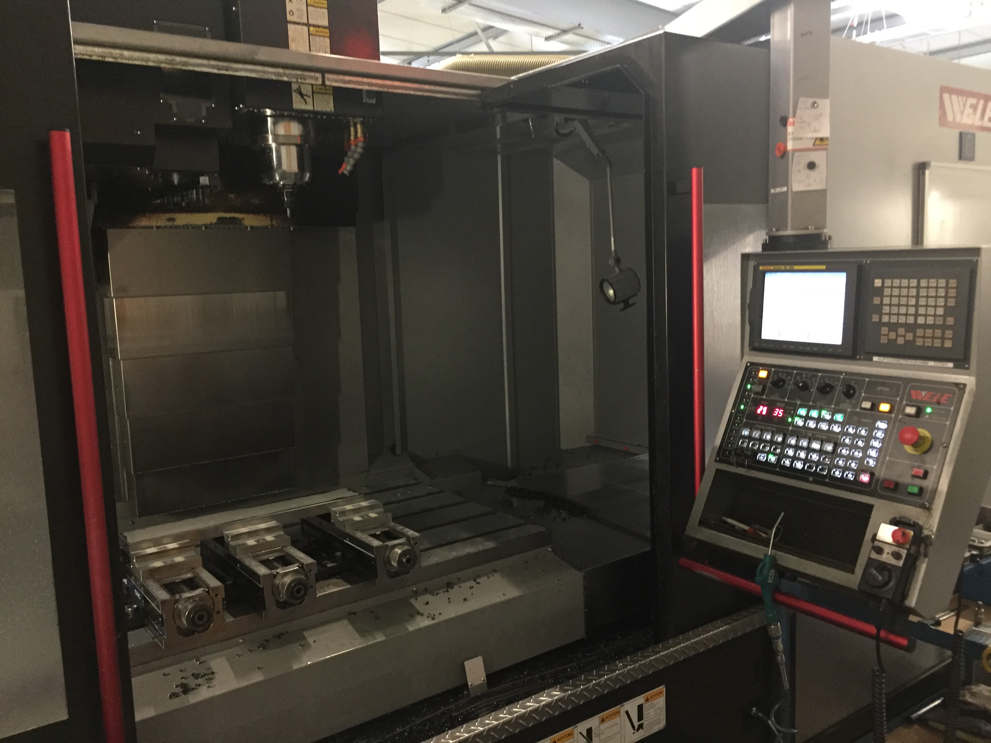
- Typ : AA 1680
- No. : 116169
- Age : 2012 with 4000 Hours

- Working area
- X - Travel : 1.600
- Y - Travel : 800
- Z - Travel : 800
- Table – Spindle : 1.000

- Table dimensions
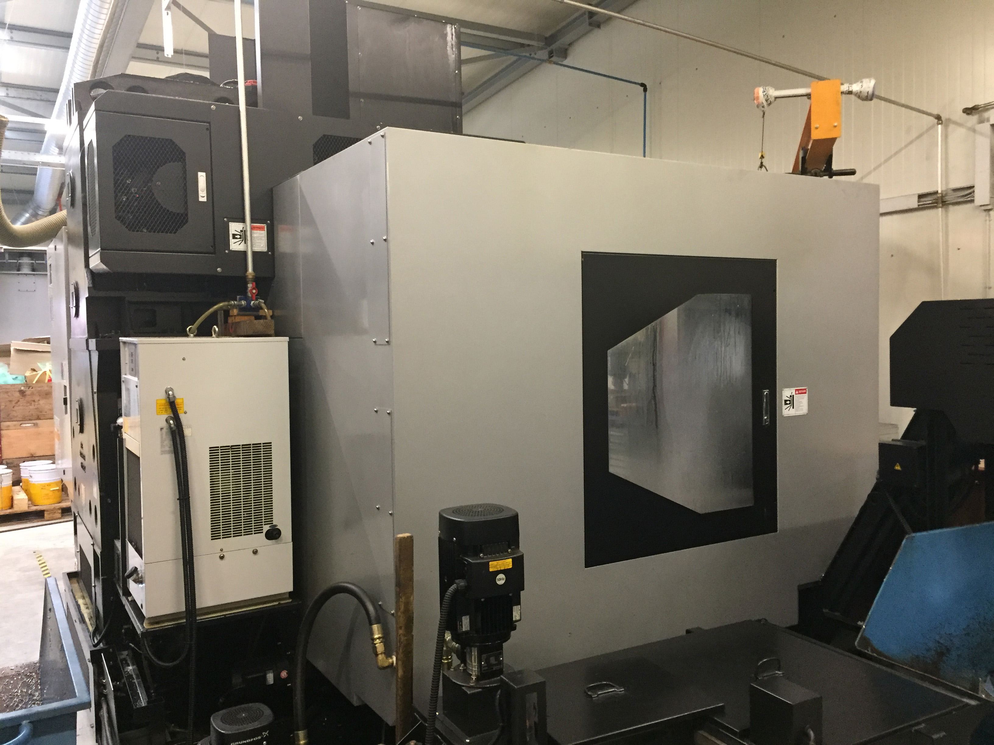
- Length : 1.750
- Width : 800
- Load : 2.000

- Spindle : Bt 40
- Speeds : 12.000 Rpm
- Power : 15 kW
- ATC : Drum 48 positions

- Dimensions:
- Length : 5.516
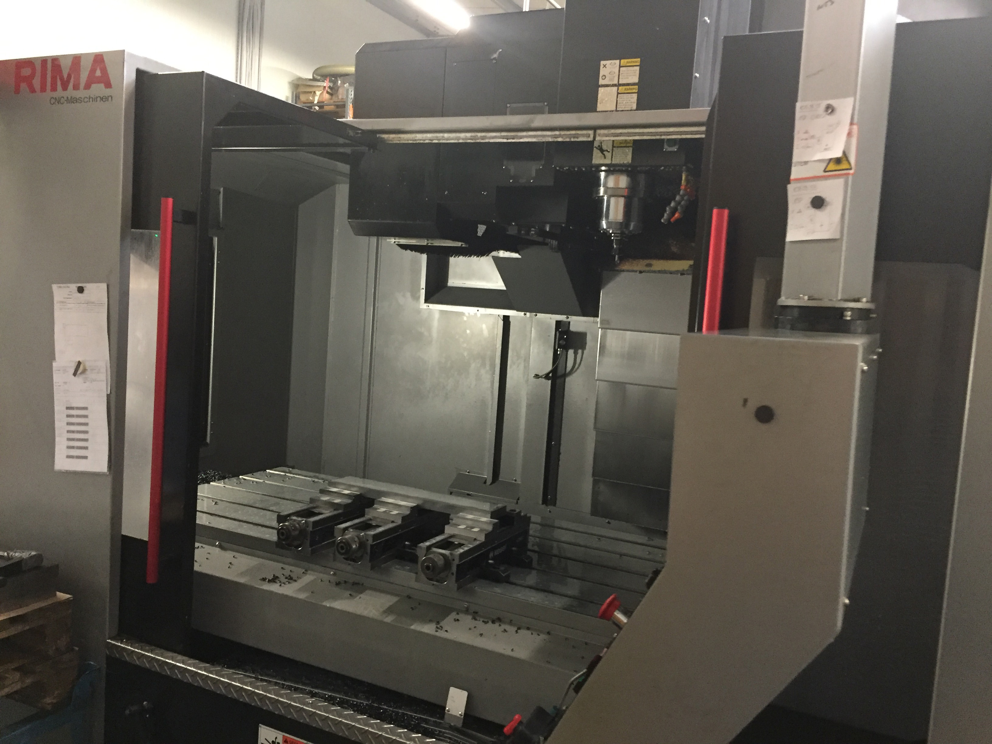
- Width : 4.374
- Height : 3.378
- Weight : 16.800

- FANUC
- Renishaw laser measuring
- Chip conveyor & High pressure coolant
- Incl. 4 big hydraulic machine vices

Please Note: The above information has been obtained to the best of our ability and belief from, and from the manufacturers where possible. It is given in good faith, but its accuracy can not be guaranteed. Accordingly, it will not form a representation or constitute contractual terms. We advise you to check any vital details!

